|  |
| --- |
|  |
| THE CAKE SHOP |
| Project Documentation of DISM (Semester II) |

SAHAR MUSHTAQ KHANJI

**Faculty** = Miss Aatika Liaquat

**Batch Code** = 1803B2

**Curriculum**= 6673

**Semester**= HDSE-2

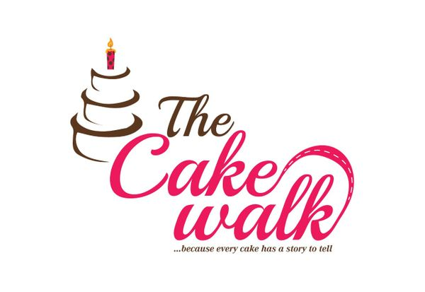

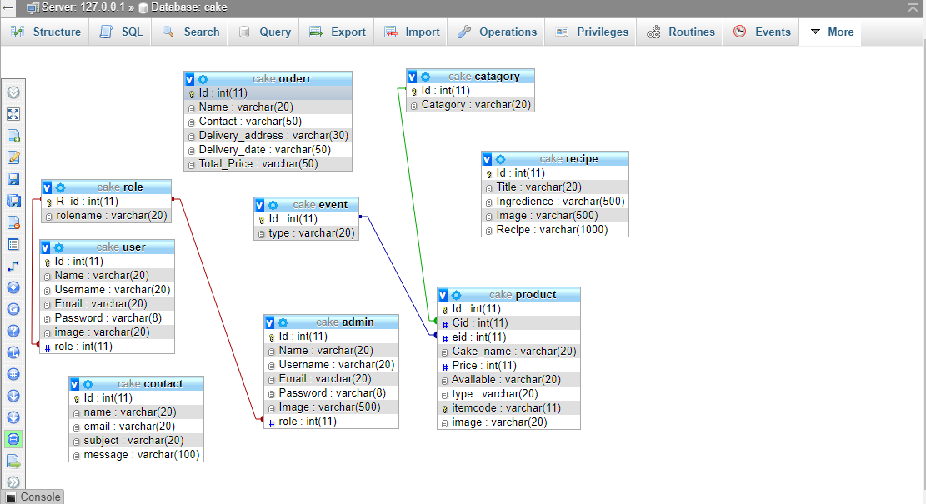

Login Page: -

This is is the entry point of our application. First of all you’ll see this page then you can select your role from combo box and if your id password matches with the id password in our data base you can see the nest page. 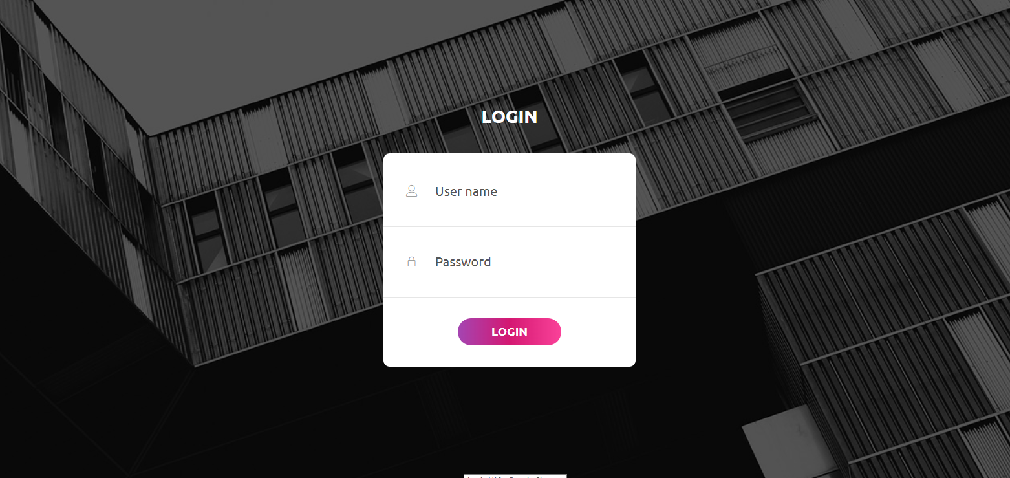

Code Snippet 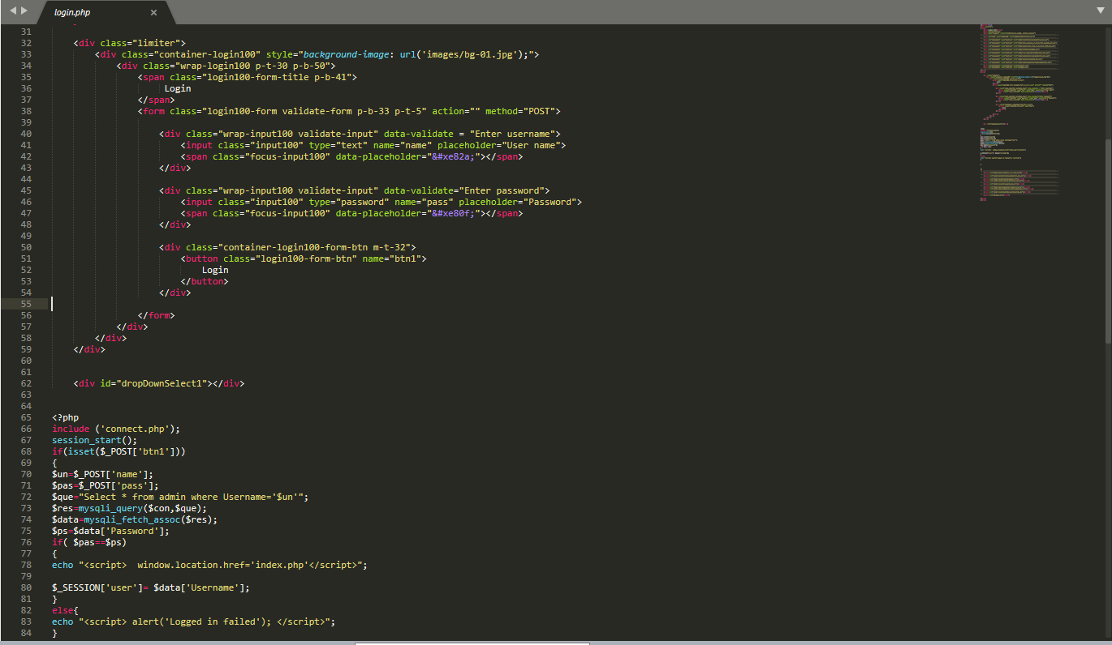



HOME:-

THIS IS OUR HOME PAGE AND ITS OUR HEADER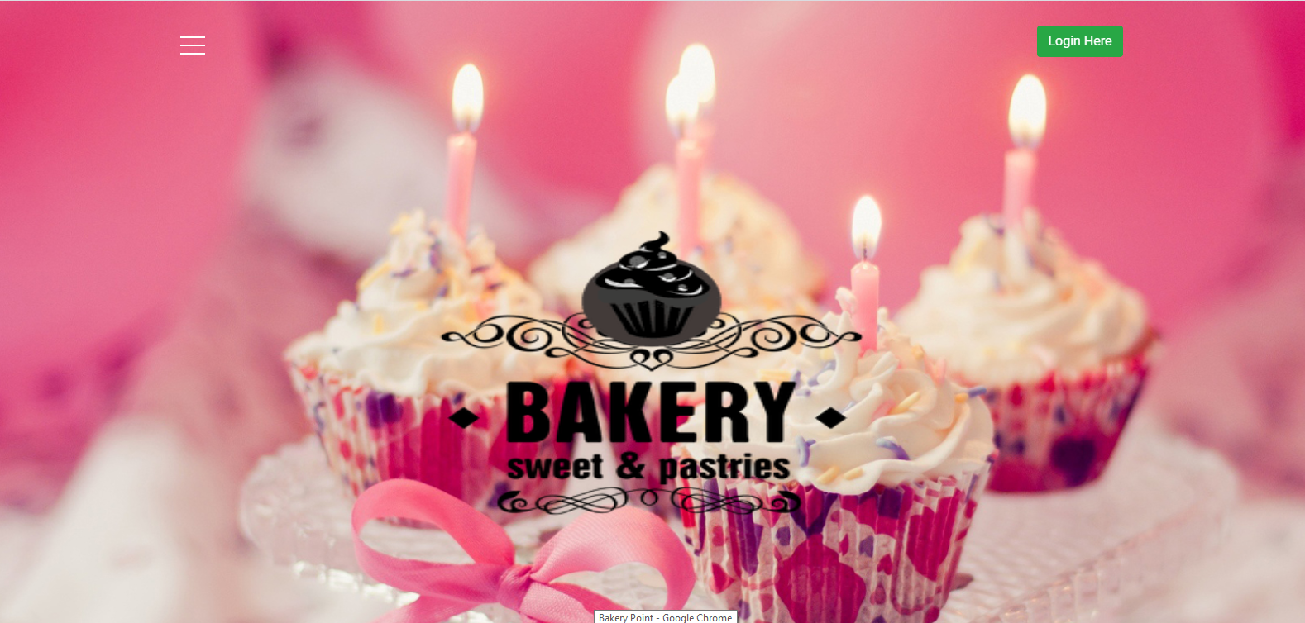

Code Snippet 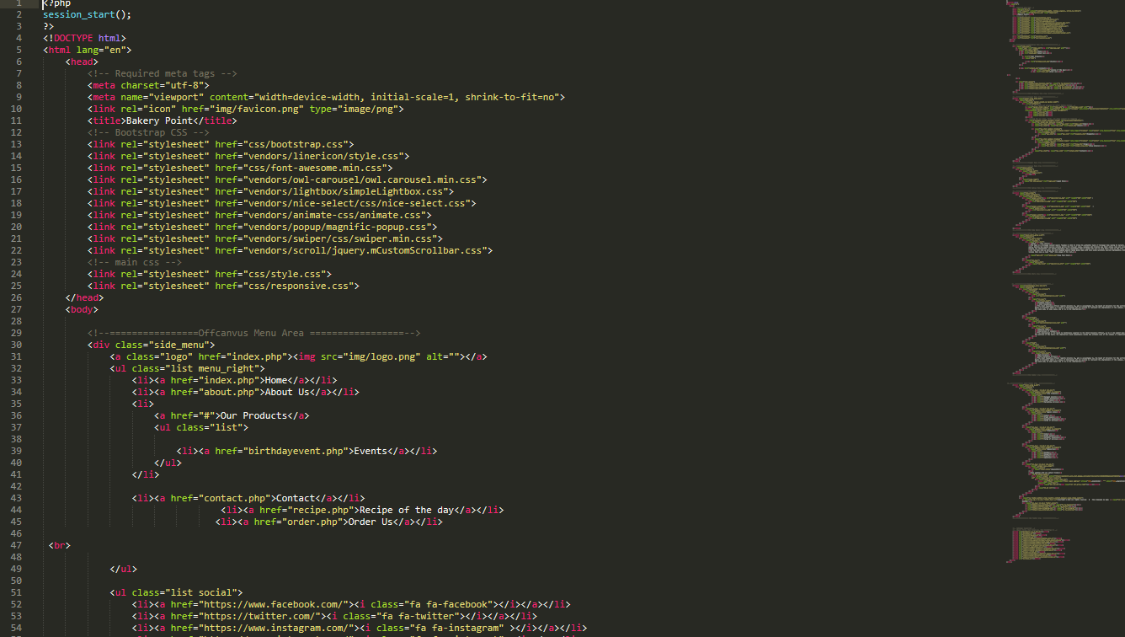



ABOUT: -

THIS IS OUR ABOUT PAGE

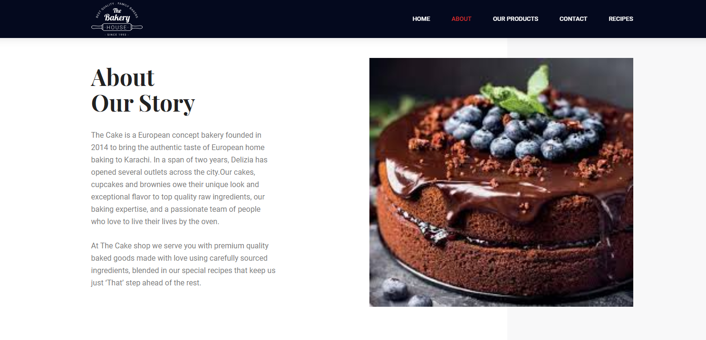

Code Snippet 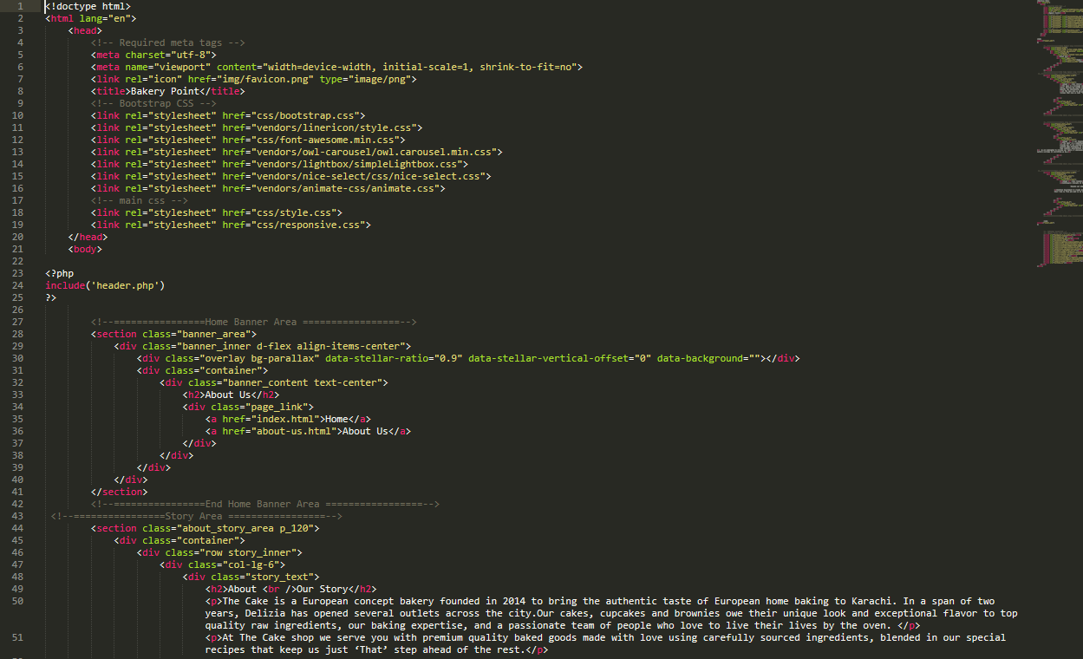



## 

EVENTS: -

HERE IS OUR PRODUCT SORT BY EVENTS

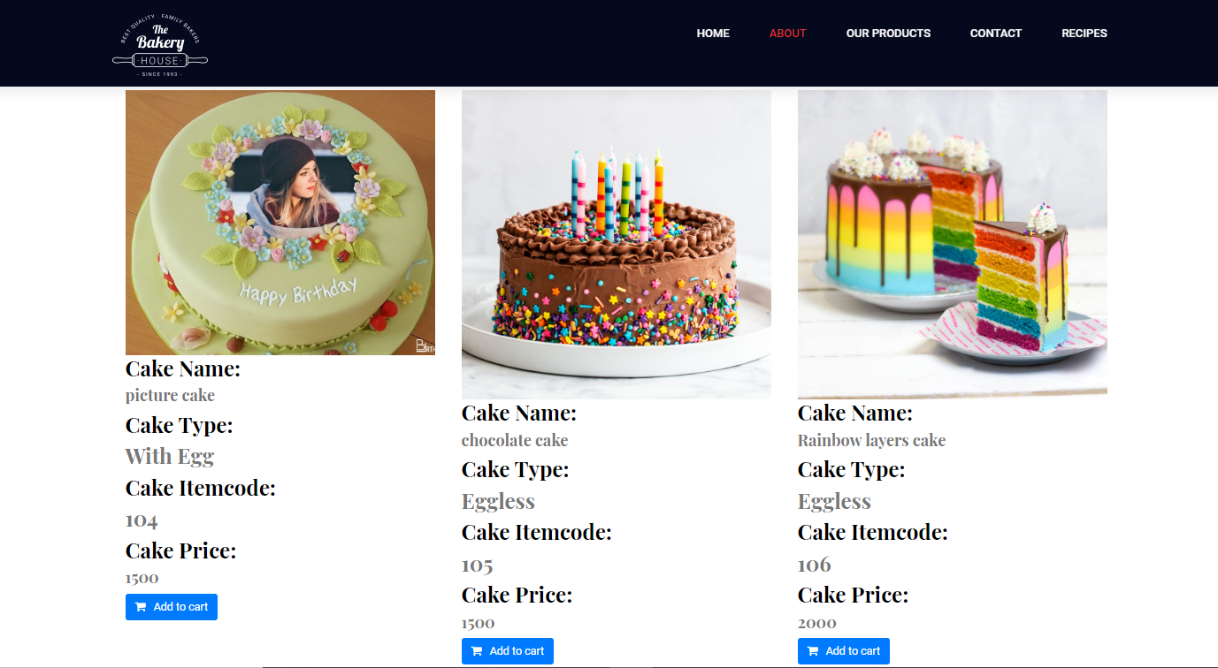

Code Snippet:-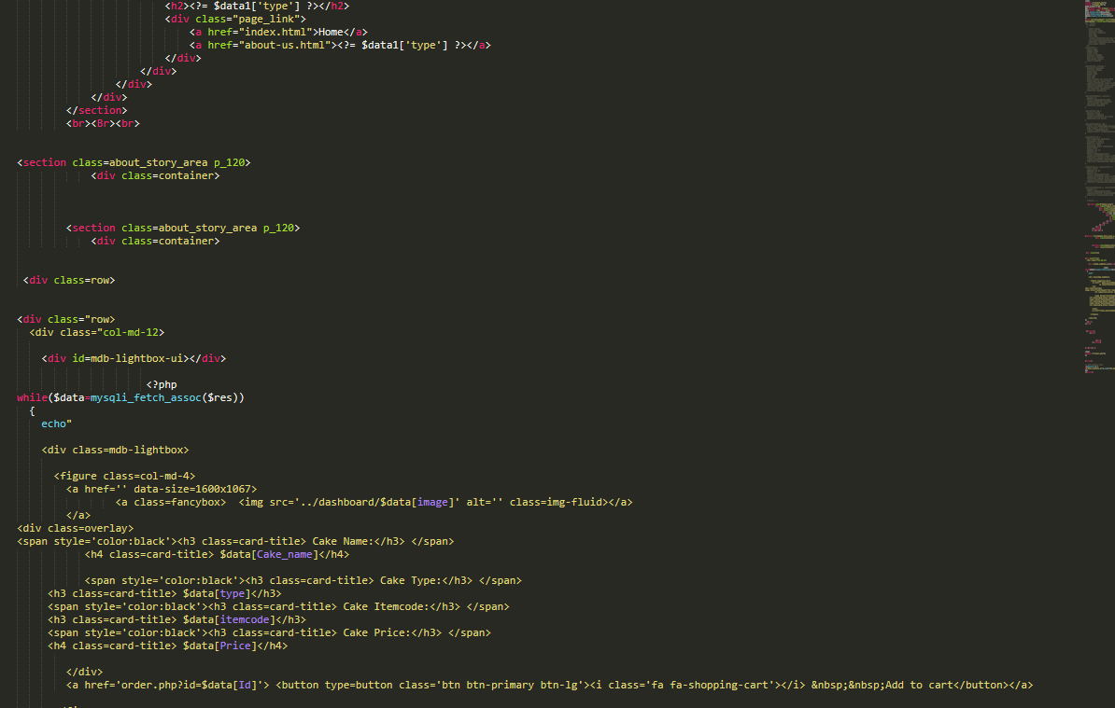



CONTACT: -

THIS IS OUR CONTACT PAGE

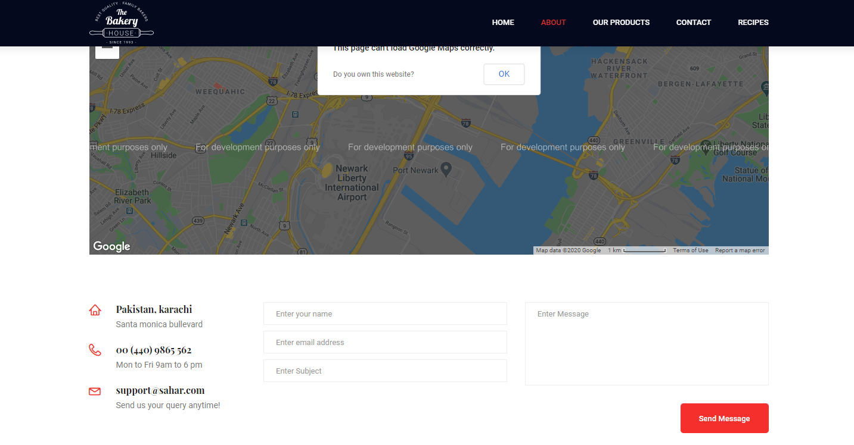

Code Snippet

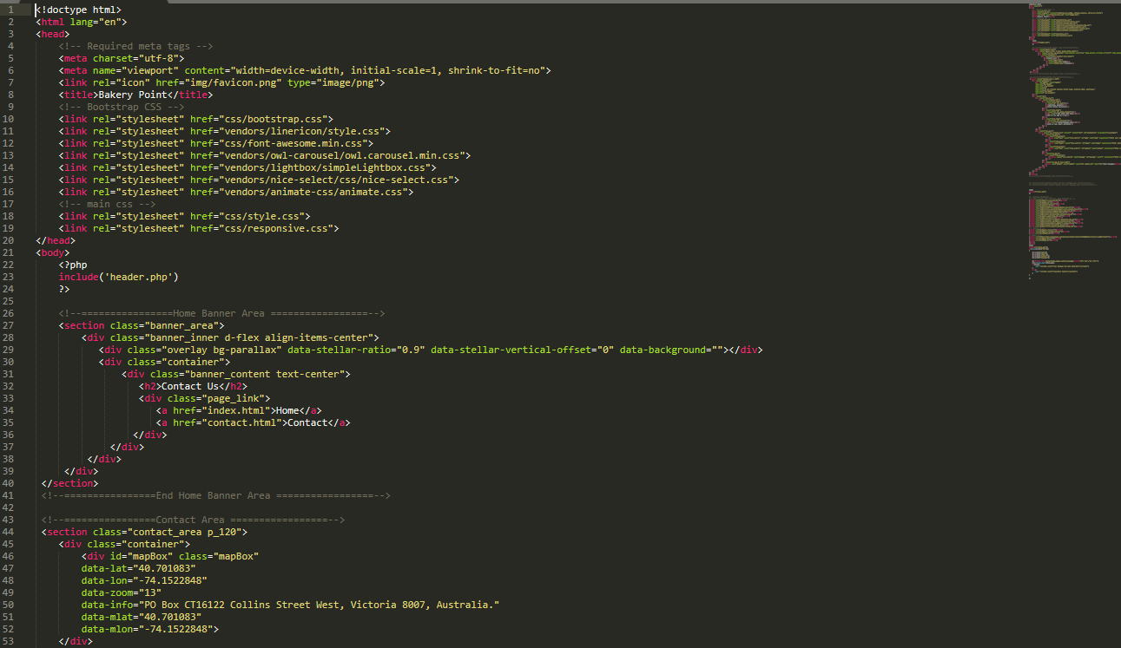



RECIPE OF THE DAY: -

This is our recipe card

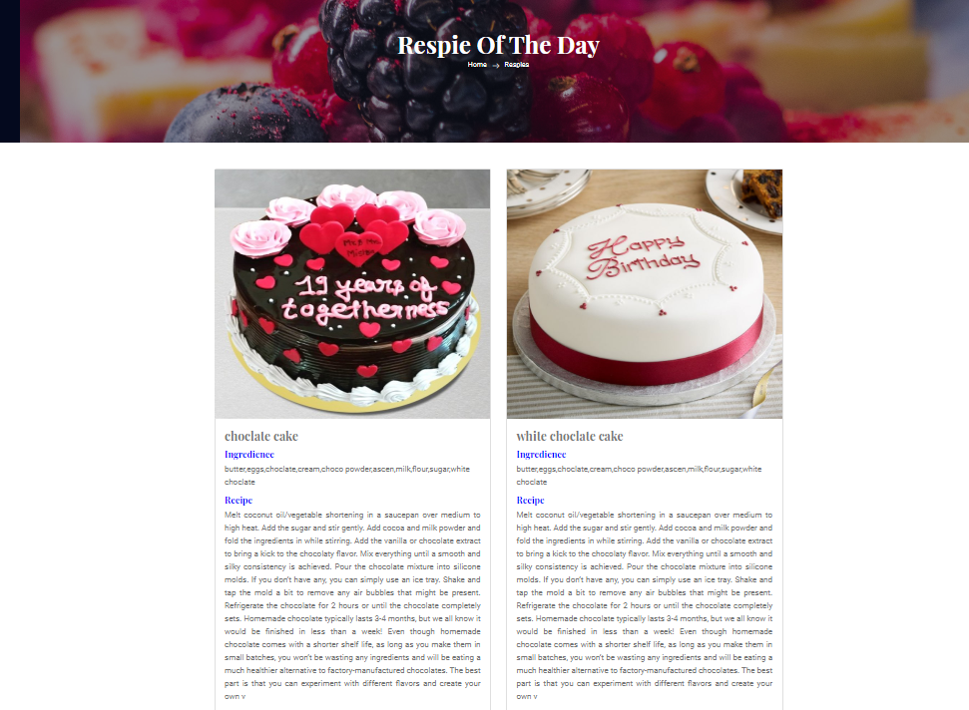

Code Snippet 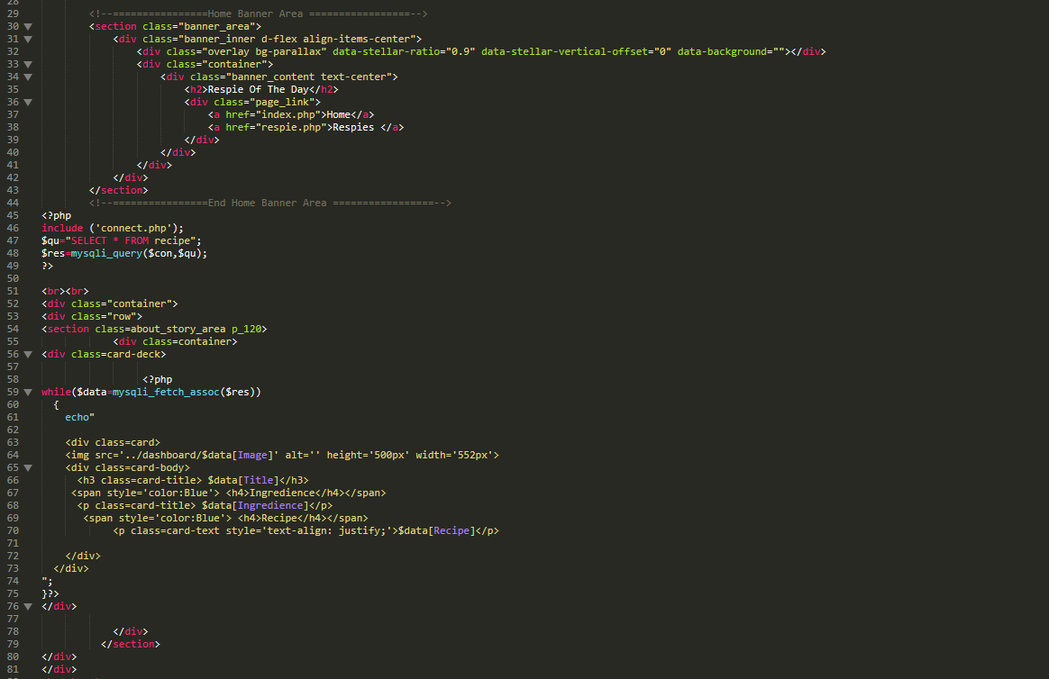



DASHBOARD: -

This is our dashboard admin

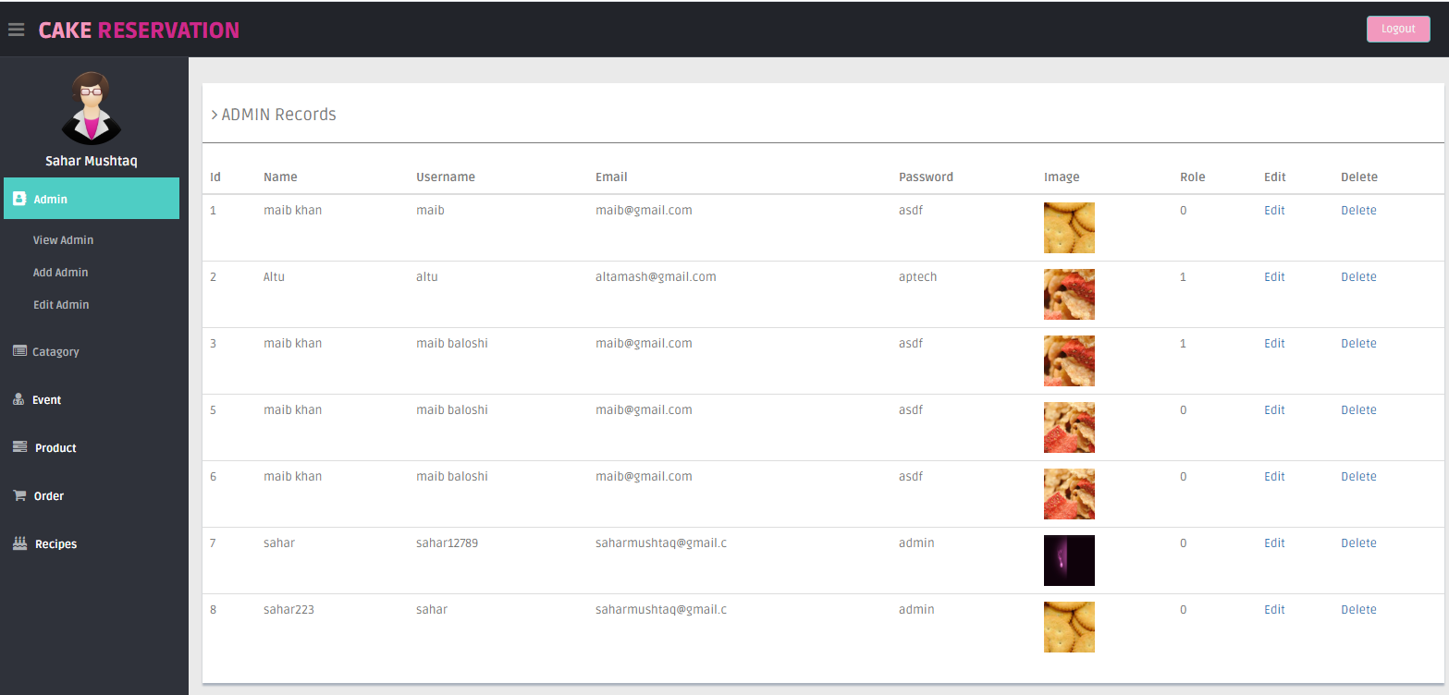

Code Snippet 